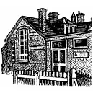

**Please contact our school office for more information on: 01485 541402**

[**office@ingoldisthorpe.norfolk.sch.uk**](mailto:office@ingoldisthorpe.norfolk.sch.uk)

**We would need to complete a DBS check for any volunteers.**

**Ingoldisthorpe Church of England VA Primary School Needs you!**



**We are looking for some community readers.**

**Do you have some spare time each week to come and listen to our children read?**